Calibration
The goal of calibration is to accurately predict battery charge and current. Knowing current it is convenient to also display the time remaining either to discharge or to charge.

Tuning the Temperature Sensor

Tuning the Voltage Sensors

Tuning the Current Sensors

Tuning the Coulombic Efficiency

Tuning the Model
An observer of the raw activity on voltage and current measurement will notice that battery terminal voltage Vb will bounce dramatically as the input current Ib changes. The characteristic of interest for charge is the relationship between the open circuit voltage Voc and the State-of-Charge (SoC) when nothing is changing at the terminals. Knowing that, and having an accurate model of the things that change when current changes, allows predicting Voc(SoC) when current changes. Then the State-of-Charge is known.

What's its used for is up to the designer. This application uses it as a surrogate for a third current sensor to isolate current sensor failures.
There are no intermediate sensors in the battery chemistry to help with that process. That would be nice.

The two main model pieces are the charging dynamics and the hysteresis. These may be represented by a dynamic linear model usually called the Randles model after a man named Randles and a dynamic non-linear hysteresis model of some sort. I relied on industry literature to discover this and to provide me with a starting point on their design. The construction I discuss elsewhere.

The method I have chosen is to embed the models in the application. Therefore I replicate the models off-line and tune using data to drive the models and compare the result to data. Assuming the sensors themselves are already calibrated, then using known Ib to drive the models I look to match Vb. The application generates a ton of data. To collect good fidelity of the Randles model, at least every 0.3 seconds is required to prevent aliasing the fast time constant. I use 0.2 seconds. The default execution speed of the application is 0.1 seconds (Dr=100 ms) for best fidelity during operation. I leave that and simply collect the data slower than it is created (DP=2). The parameter DP sets how often to print the application data out UART while it runs at 0.1 s (100 ms) seconds update. Then the off-line model may run its dynamics at 0.2 s without aliasing. If aliasing is observed by divergence of the Randles model, it has been mis-tuned. So long runs at 0.2 s are collected and drive the model.

There are two processes performed simultaneously. Because for the model tuning process to work, the off-line model must agree with the on-line application. The Baseline of Figure 2 is declared as such because the model may be seen to agree with the application by overlaying data. Then with that agreement assured, and the same 'Ib' input to both then the model can be tuned to make the 'Vb' agree.

The off-line data is marked as '_ver' for 'verification.' In Figure 2you can see that 'ib_charge_s_ver' overlays 'ib_charge_s' which intern overlay 'ib_in_s' and 'ib_sel.' That last variable, 'ib_sel' is the final, selected value of current that is driving everything.

This verifies the integrity of the models required for the matching process to be valid.
A glossary is included in Error: Reference source not foundError: Reference source not found to help. Figure 1 Is a Functional Block Diagram of the data match process. There are many modes to run this match. The one illustrated is one that inputs current to all paths and outputs voltages from each block. It is useful for troubleshooting to sometimes drive one path with a voltage from another path but the simplest one shown here is the most straightforward for data match discussed in this tuning section.
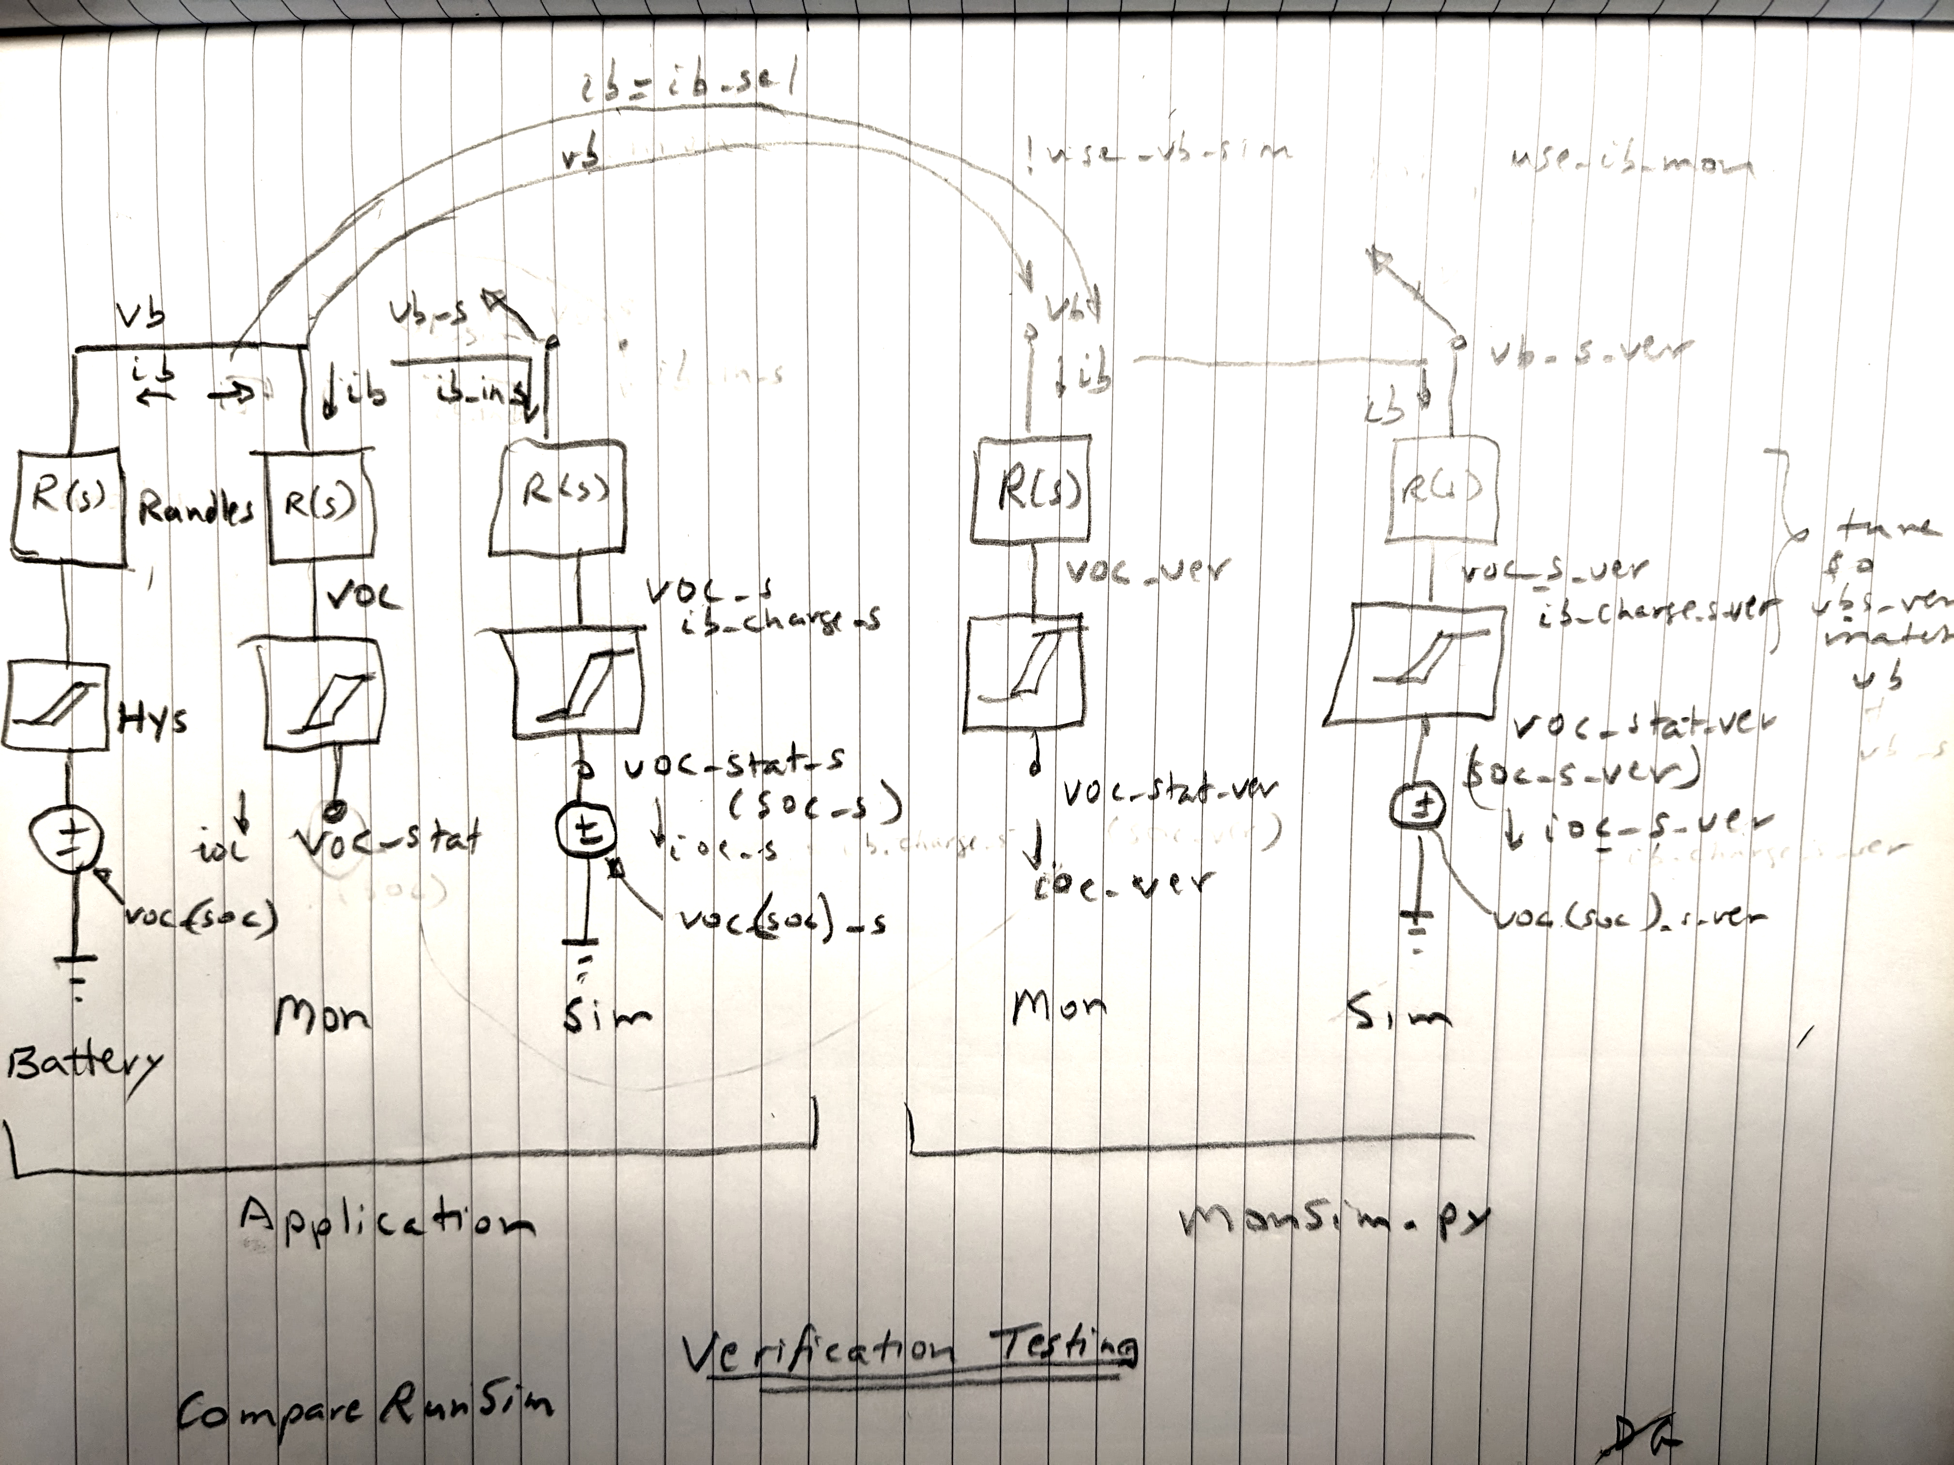Figure 1: Verification Test Functional Block Diagram
Before beginning tuning I check the following matches for the four Mon/Sim legs of Figure 1:
- 'dv_hys' 'dv_hys_s' 'dy_hys_ver' 'dv_hys_s_ver'
- 'dv_dyn' 'dv_dyn_s' 'dv_dyn_ver' 'dv_dyn_s_ver'
- 'soc' 'soc_s' 'soc_ver' 'soc_s_ver'
- 'vb' 'vb_s' 'vb_ver' 'vb_s_ver'

The characteristics most readily available to tune a match between off-line vb, 'vb_s_ver' and on-line vb, 'vb' are
- Resistance values in the off-line Randles models: r_ct, r_dif, r0
- Time constant values in the off-line Randles models: tau_ct, tau_dif
- Hysteresis tables in the off-line models: x_dv, y_soc, t_r, t_dv_max, t_dv_min
- voc(soc) table in off-line models: t_x_soc, t_y_t, t_voc
- Diffusion time constant in the off-line models: tau_dif
- Battery capacity, NOM_UNIT_CAP
- Coulombic charge efficiency, COULOMBIC_EFF

Quick studies are possible using simple scaling parameters. The most useful are
Resistance scaling of all the resistance values in the off-line Randles models: 'sres_in'
Time constant scaling in the off-line Randles models: stauct, staudif
Hysteresis scaling of the off-line models: 'scale_hys_mon_in' and 'scale_hys_sim_in'

The initial generation of these model elements using a Battleborn prototype system on my RV truck was complicated, time consuming, and full of guess work until data congealed in a match. Eventually, small changes in test parameters and special testing to isolate parameter effects won out.
The approach of confirming all four legs of this paradigm match, drives quality into the process.
This CHINS installation does not yet know what the Coulombic Efficiency and capacity are. Several runs and recharges to full discharge are required to triangulate those values. For now, the Battleborn observations are used: 0.985 and 105 A-h.

Black Box Paradigm
To review and add perspective: the tuning process may be considered a black-box process.

There are three signal measurements. 'b' stands for 'bank' consolidation of multiple batteries in a bank
- Current into the battery terminals, Ib
- Voltage at the battery terminals, Vb
- Temperature of the battery chemistry, Tb

There are four models each with two components
- Application BatteryMonitor Randles
- Application BatteryMonitor Hysteresis
- Application BatterySim Randles
- Application BatterySim Hysteresis
- Off-line Python BatteryMonitor Randles
- Off-line Python BatteryMonitor Hysteresis
- Off-line Python BatterySim Randles
- Off-line Python BatterySim Hysteresis

There are many characteristics to observe
- Capacity, Coulombs from counting – observe exhaustion and saturation for various conditions to triangulate
- Current step response – initial step and subsequent settling times to extract time constants. Hold at least 3x longer than hysteresis time constant (~45 minutes)
- Predicted voc(soc) – hysteresis time constant and resistance values
- Predicted voc(soc) – mismatch between discharge-charge
- Long-term settling – hysteresis time constant (=1/RC)

There are an infinite number of data conditions to observe, such as
- Moment of saturation – accumulated current measurements should be zero for a perfect model match result. Measures Coulombic Efficiency and confirms sensor calibrations
- Moment of exhaustion – need to know minimum Coulomb state at all operating temperatures
- Slow discharge-charge – schedule development because hysteresis small
- Rapid discharge-charge
- Step current changes – detection of gains especially Randles resistance
- Difference between discharge-charge of the voc(soc) curve. It should be zero and flat for a perfect model match result. Adjust dynamics, scalars, and schedules.
- Leverage the fact that the Randles model always passes output current equal to input current
- Leverage the fact that the linear Randles model is linear and therefore symmetrical for discharge-charge
- Leverage the fact that the hysteresis will be near zero for very slow discharge rates

The task is to match the predicted Vb of the off-line Sim model to the measured Vb under all operating conditions. And ensure that there remains a perfect match between the four component models at all times. Then we can use the models for anything.

A perfect match won't be possible. The difference between discharge-charge of voc(soc), Volts at State-of-charge, is a reasonable measure of overall success.

Initial Tuning
The very first step is to calibrate the sensors. After that we assume they are valid. It will become obvious if they are incorrect, unfortunately after a lot of work. So do that first, carefully.

The next first step is to make sure that all the model components are consistent with each other. The real world data does not have to match at this point. There are four versions of the Randles model and four versions of the hysteresis model. The application has two of each, one set called in the BatteryMonitor object and the other set called in the BatterySim object.

The off-line model has two of each and every effort was made to duplicate the C++ code of the application in Python code of the off-line model. The plot sets carefully overlay all four models to allow them to be validated easily.

Driving the models with data is a time tested way to drive model verification. Collect data from the application and drive the models and view matches. So the basic verification is to collect Ib, Vb, and Tb. Drive the off-line model with the Ib and Tb data and over-plot Vb.

Data Collecting
There are two ways to gather data: transient verbose continuous streaming into CoolTerm at 0.1 or slower intervals and steady-state fault logging at 30 minute intervals. Interestingly, the slow fault logging is sufficient for most tuning except Randles model.

The Randles model is also the one that makes most sense to tune first, since it is linear and symmetrical. After it is tuned, assuming it doesn't vary with operating condition, it is relatively easy to extract the hysteresis.

To generate enough degrees of freedom for tuning we will need some charging, some discharging, rapid and slow, all state-of-charge.

Tuning Step 1
The results of initial tuning are shown in Figure 2, Figure 3, and Figure 4 for transients soc=0.9, transients soc=0.8, and steady-state fault log from soc=0.9-1.0. For these I've made following initial changes:
- schedule tune to center about steady-state
- Randles tune all resistances by 1.6x Battleborn
- Randles tune tau_dif to be 0.3x Battleborn
- Hysteresis variable
The hysteresis transfer function is of the form:

tau = Rh * gain_scalar / (Rh * Ch * tau_scalar * s + 1)

So we need to make two adjustments to match data. These I call s_hys, and s_cap. The first is the gain_scalar and the second is the tau_scalar. Baseline is Battleborn:

y_soc_bb = [0.0, 0.5, 1.0], soc brkpt
x_dv_bb = [-0.7, -0.5, -0.3, 0.0, 0.15, 0.3, 0.7], dv_hys brkpt
t_r_bb = [0.019, 0.015, 0.016, 0.009, 0.011, 0.017, 0.030,
0.014, 0.014, 0.010, 0.008, 0.010, 0.015, 0.015,
0.016, 0.016, 0.016, 0.005, 0.010, 0.010, 0.010]; Rh values
t_dv_max_bb = [0.7, 0.3, 0.15]
t_dv_min_bb = [-0.7, -0.5, -0.3]
hys_cap = 3.6e3 tau_null = 3.6e3 * 0.005 = 18 s; Ch value

Condition | Randles s_res | Randles  s_tau_dif | Hysteresis  s_cap_chg | Hysteresis  s_hys_chg | Hysteresis  s_cap_dis | Hysteresis  s_hys_dis
0.9-1.0 Flt | 1.6 | 0.3 | 90 | 8 | 10 | 2
0.9 Trans | 1.6 | 0.3 | 90 | 4 | 10 | 0.7
0.8 Trans | 1.6 | 0.3 | 4 | 1.5 | 40 | 2
Table 1: CHINS Battery Initial Tuning #1 – Non-schedule data

The Randles values in the table apply to all the Randles resistances simultaneously and to the diffusion time constant. The hysteresis values in the Table apply to t_r and hys_cap, (Rh and Ch).
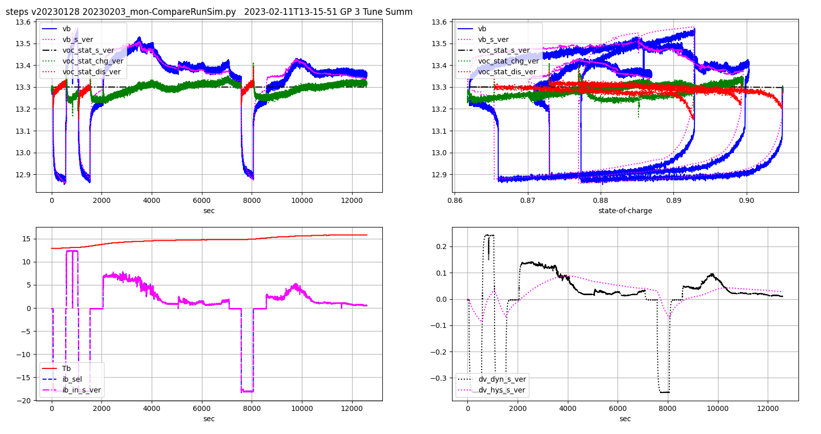Figure 2: CHINS Transients Around soc=0.9 Tune 1

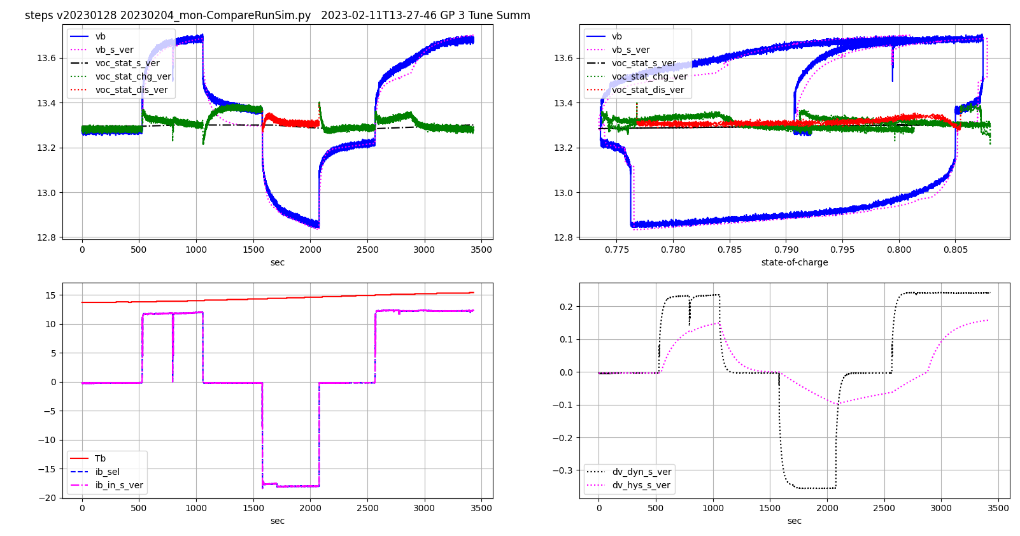Figure 3: CHINS Transients Around soc=0.8 Tune 1

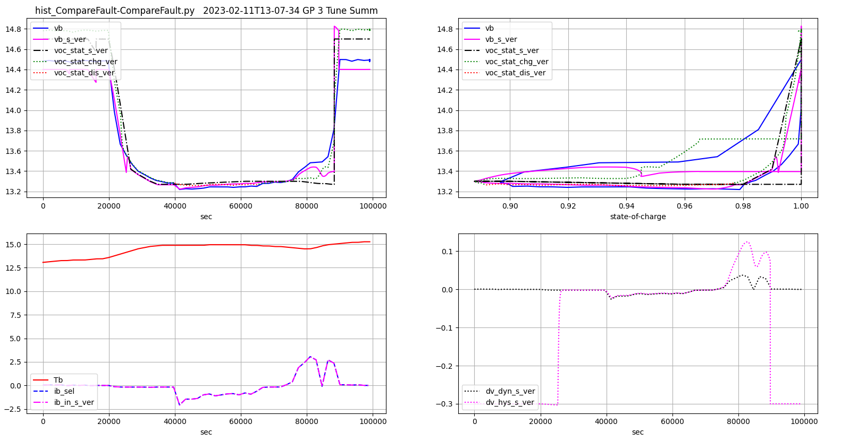Figure 4: CHINS History soc=0.9-1.0 Tune 1
The end result of this tuning step is a difference between discharge-charge voc(soc) of +/-0.05 volts – see the red and green lines voc_stat_chg_ver and voc_stat_dis_ver. This is very good and would cause an uncertainty of about 20% soc. This should make a useful reference model.

EKF differences, not shown, should sort themselves out after re-running the application with these changes. Anyway, you should not spend much time looking at EKF until the rest of the application is tuned and re-run.

Tuning Step 2
The challenge is to turn these results into hysteresis schedules. This is denoted as myCH_Tuner=3 in the Python code. The CHINS values are:

y_soc_ch = [0.8, 0.86, 0.92, 0.95]; soc brkpt
x_dv_ch = [-0.1, -.05, -.04, 0.0, 0.06, 0.07, 0.1]; dv_hys brkpt
t_r_ch = [0.004, 0.004, 0.4, 0.4, 0.4, 0.010, 0.008,
0.003, 0.003, 0.4, 0.4, 0.003, 0.003, 0.003,
0.003, 0.003, 0.4, 0.4, 0.003, 0.003, 0.003,
0.03, 0.03, 0.4, 0.4, 0.08, 0.08, 0.08]; Rh values
t_dv_max_ch = [0.3, 0.3, 0.3, 0.3]
t_dv_min_ch = [-0.3, -0.3, -0.3, -0.3]
hys_cap = 1e4 tau_null = 1e4 * 0.4 = 4000 s; Ch value
Table 2: CHINS Initial Hysteresis Tuning - Changed Later

and the results results are shown in Figure 5, Figure 6, and Figure 7.

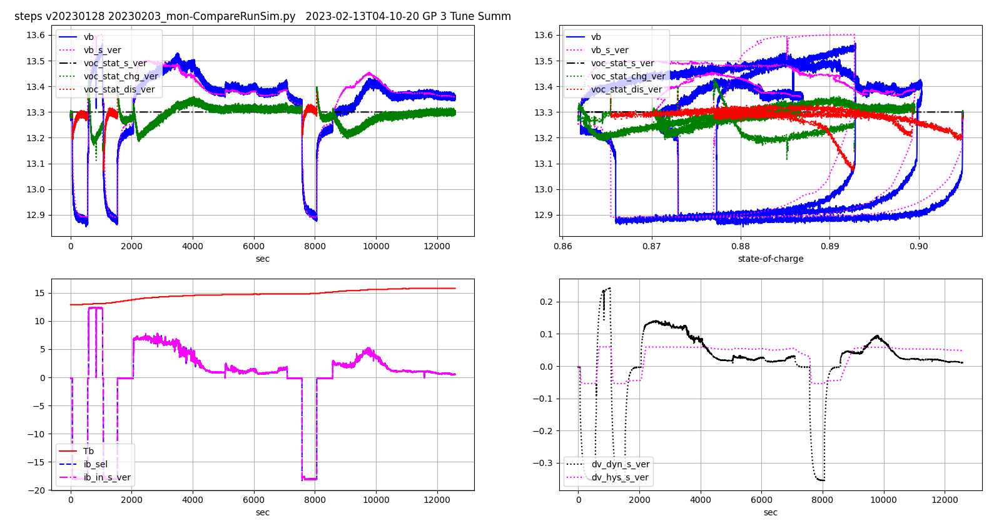Figure 5: CHINS Transients Around soc=0.9 Tune 2

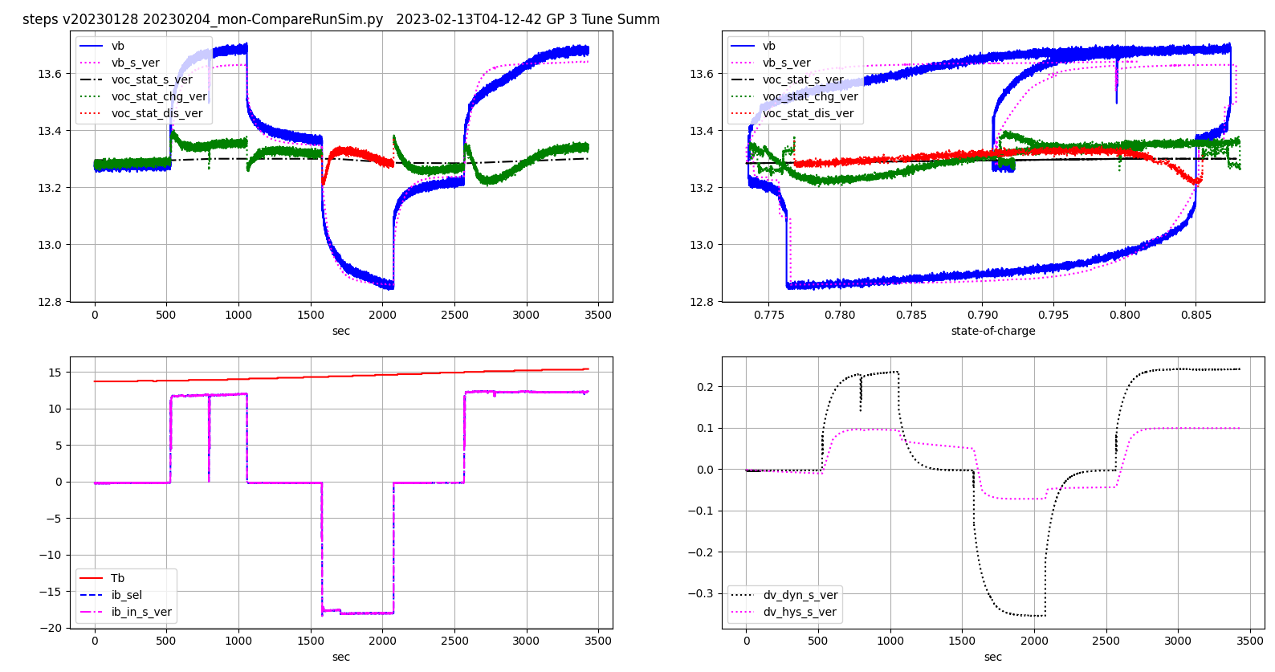Figure 6: CHINS Transients Around soc=0.8 Tune 2

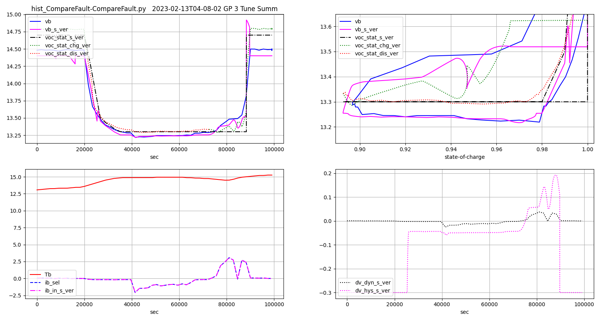Figure 7: CHINS History soc=0.9-1.0 Tune 2

Now the end result of this tuning step is a difference between discharge-charge voc(soc) of between 0.05 and 0.10 volts – see the red and green lines voc_stat_chg_ver and voc_stat_dis_ver. This is nearly as good as tuning attempt 1 and would cause an uncertainty of about +/- 20% soc. This should make a useful reference model.

But it could be improved. We can never match charging transients because the hysteresis model lacks a restriction on the supply current into the hysteresis capacitor. See the red ellipses on the figures. This should be added in a future version. Also the 0.9-1.0 tuning lacks transient data to properly tune. This should be gotten later. Also we don't have the full state-of-charge range. The modeling and scheduling is especially important near zero charge to alert the user that they're running low. This should be gotten later. Finally the hysteresis capacitance is 10000 f. The Battleborn was 3600 and the maximum value to allow 15 A of the 30 A charge controller to charge at 0.0014 v/s observed is about 10000 f. So next time around I would tune everything with 3600 just to be foolishly consistent.

When the restriction on hysteresis supply is added later, there are a couple other improvements needed:
- Set tau_ct to the present tau_dif. The present tau_ct is too fast to be useful and doesn't seem to exist anyway.
- The present tau_dif is probably the 400 second hysteresis time constant. So delete it and use the non-linear hysteresis model instead. Since that is non-linear than tau_dif becomes undefined
- This allows minimum update time to be as long as 10 seconds (tau_ct ~ 20 for CHINS). This further allows much more prolonged data capture and faster design times. I would still execute the monitor at 0.1 seconds to capture all the 1 Hz bandwidth sensed current changes. If we miss peaks the accumulated Coulomb counting errors would be large.

EKF differences, not shown, should sort themselves out after re-running the application with these changes. Anyway, you should not spend much time looking at EKF until the rest of the application is tuned and re-run. We will need to keep an eye on the EKF during these early times because the voc(soc) schedule for CHINS is flat at high soc. This EKF's ability to solve to a flat line is TBD. A pure numerical solver would not be able to. The EKF has a soc input to favor it 'probably' close to the Coulomb counter.

A couple tips on tuning hysteresis:
- The resistance is high around null to create a hysteresis band. Tau = R*C so check that Tau is about 2.5 hours, or 7500. This will have to be tuned again to match the real world battery relaxation time period
- use the right side to tune the shape of increasing dv / current and the left for decreasing
- Set s_hys_chg/dis = 0 to see what the scripts think the ideal R is
- Need 45 minute transients to see the slow ~500 second hysteresis time constant.
- You can calculate requirements for the hysteresis capacitance, C. When running with s_hys_chg/dis = 0 as described a couple lines previous, the required rate of change of voltage is available. The maximum supply current is known. Therefore the maximum C that allows charging to keep up with the required (check =observed) voltage is known.

Let's revisit the purpose of this tuning. The accuracy of the things we're tuning affect how well the EKF tracks reality for purposes of detecting sensor faults. The thresholds of faults have been tuned out to +/-0.2 soc and beyond due to unmodeled variations. So the <0.05 V tuning accuracy that we observe above are within the needs of the fault detection. This level of effort is needed to achieve the +/-0.2 result on thresholds, however.

It's fair to ask if the sensor redundancy is worth the effort. I am considering simplifying to one current sensor and simply throwing a generic, displayed fault light when we're sure there's something wrong.

Schedule Tuning – at the end
The original process used .xls/.ods spreadsheets. Lately I used the plots from tuning hysteresis. When the red and green curves above were aligned after tuning hysteresis, I would tune voc(soc) to run the schedule line (black) through the middle of the red and green. Spreadsheets not required.

Yet More Tuning
I was able to eliminate the charging supply current problem mentioned with the 'ellipses' in the previous section. I scheduled a scalar on the ib input to the hysteresis model. The scalar is a function of dv_hys like the resistance model is and works well. Here's the final resistance / scalar schedules, Table 4, where t_r is the resistance schedule and t_s is the scalar schedule. The suffix '1' is for the CHINS battery. '0' is for the Battleborn battery that did not need additional scaling. The t_s schedule for Battleborn is unity 1.

And the final tuned transients appear below in Figure 8, Figure 9, and Figure 10. Notice that the 0.9 – 1.0 fault run map is missing and a low content transient is added. The reconstruction of transient behavior from 30 minute fault data using CompareFault.py does not do a good job of capturing the Randles dynamics so the hysteresis modeling is poor. Eventually I modified the Python model to simply run to minimum or maximum hysteresis depending on negative or positive sign of charge current. The Randles model in the reconstructed mode is ignored. So don't use it to tune hysteresis logic or schedules. But it can be used to estimate voc_soc scheduling.

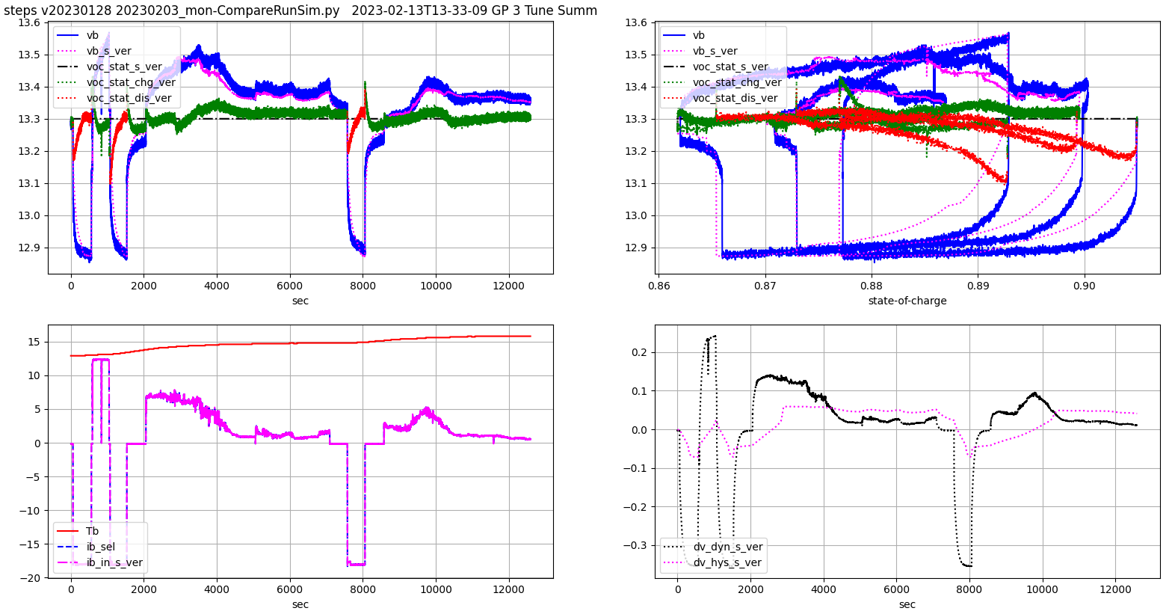Figure 8: CHINS Transients Around soc=0.9 Tune Final

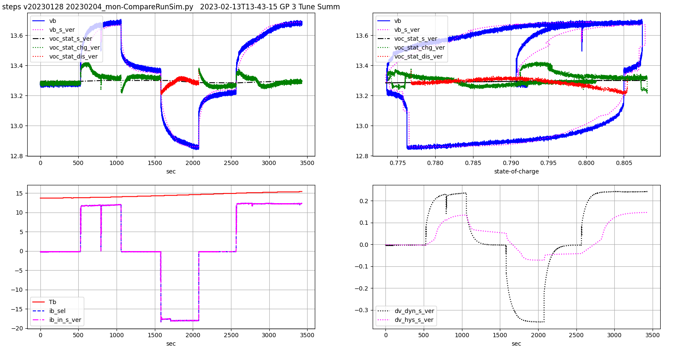Figure 9: CHINS Transients Around soc=0.8 Tune Final

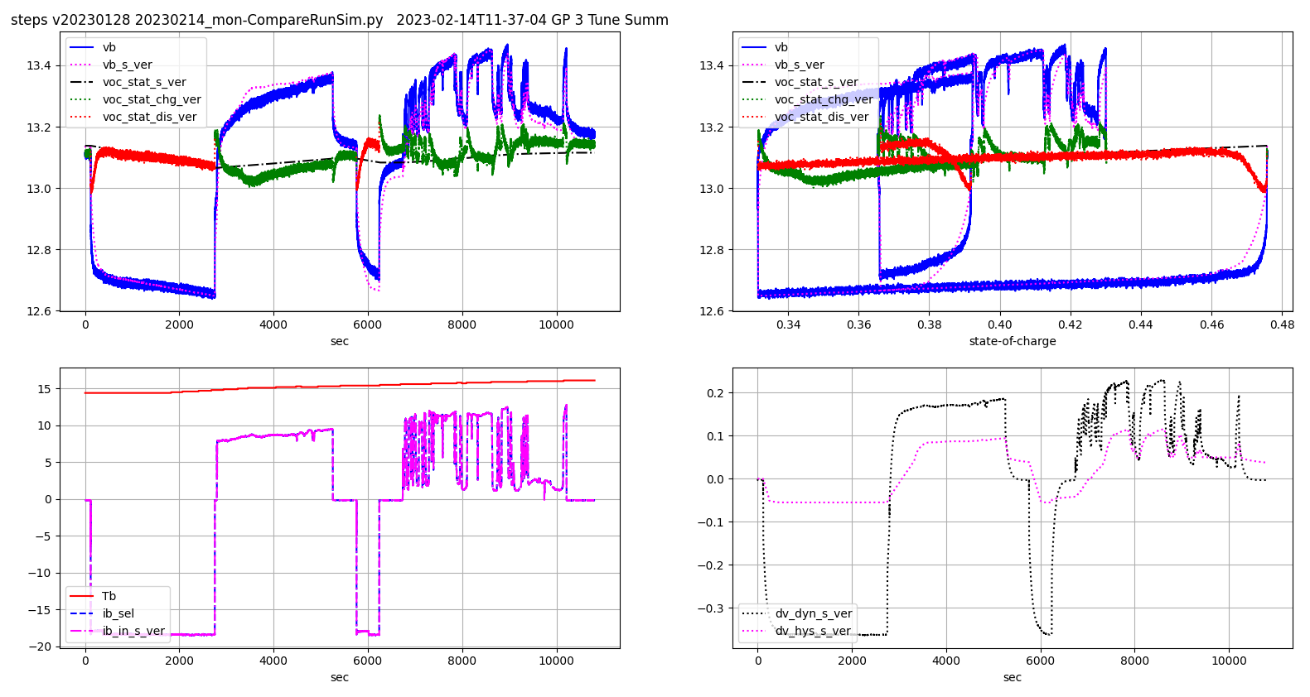Figure 10: CHINS Transients Around soc=0.4 Tune Final
Final accuracy.

Condition | Randles r_0 | Randles  r_ct | Randles  tau_ct
all | 0.0138 | 0.0059 | 24.9
Table 3: CHINS Battery Final Tuning

Schedule is flat.

self.cap1 = 1e4 # scaled later
t_soc1 = [.47, .75, .80, .86]
t_dv1 = [-.10, -.05, -.04, 0.0, .02, .04, .05, .06, .07, .10]
schp4 = [0.003, 0.003, 0.4, 0.4, 0.4, 0.4, 0.010, 0.010, 0.010, 0.010]
schp8 = [0.004, 0.004, 0.4, 0.4, 0.4, 0.4, 0.4, 0.4, 0.014, 0.012]
schp9 = [0.004, 0.004, 0.4, 0.4, .2, .09, 0.04, 0.006, 0.006, 0.006]
t_r1 = schp4 + schp8 + schp8 + schp9
t_dv_min1 = [-0.3, -0.3, -0.3, -0.3]
t_dv_max1 = [0.3, 0.3, 0.3, 0.3]
SRs1p4 = [1., 1., .2, .2, .2, .2, 1., 1., 1., 1.]
SRs1p8 = [ 1., 1., .2, .2, .2, 1., 1., 1., 1., 1.]
SRs1p9 = [ 1., 1., .1, .1, .2, 1., 1., 1., 1., 1.]
t_s1 = SRs1p4 + SRs1p8 + SRs1p8 + SRs1p9
Table 4: CHINS Final Hysteresis Scheduling
t_x_soc1 = [-0.100, -0.060, -0.035, 0.000, 0.050, 0.100, 0.140, 0.170, 0.200, 0.250, 0.300, 0.400, 0.500, 0.600, 0.700, 0.800, 0.900, 0.980, 0.990, 1.000]
t_y_t1 = [5., 11.1, 11.2, 40.]
t_voc1 = [4.000, 4.000, 4.000, 4.000, 4.000, 4.000, 4.000, 5.370, 10.042, 12.683, 13.059, 13.107, 13.152, 13.205, 13.243, 13.284, 13.299, 13.310, 13.486, 14.700,
4.000, 4.000, 4.000, 4.000, 4.000, 4.000, 6.963, 10.292, 12.971, 13.025, 13.059, 13.107, 13.152, 13.205, 13.243, 13.284, 13.299, 13.310, 13.486, 14.700,
4.000, 4.000, 4.000, 9.000, 12.453, 12.746, 12.869, 12.931, 12.971, 13.025, 13.059, 13.107, 13.152, 13.205, 13.243, 13.284, 13.299, 13.310, 13.486, 14.700,
4.000, 4.000, 4.000, 9.000, 12.453, 12.746, 12.869, 12.931, 12.971, 13.025, 13.059, 13.107, 13.152, 13.205, 13.243, 13.284, 13.299, 13.310, 13.486, 14.700]

Table 5: CHINS Final voc(soc)

Finally
Make sure to test the logic after making these extensive tuning changes. Following are some of the problems I found and how I fixed them.
- soc_ekf != soc steady-state. In the model with tight constraints, there's no reason the EKF should differ at steady-state. When I entered the new voc_soc schedule it had a long flat section. Normally, such flat sections, or valleys even, cause solvers to be indeterminate. The EKF does a fair job of finding a solution because it has soc_ekf as a reference, an independent Coulomb counter, in addition to the voc_stat error. But it's not perfect. I added a 0.01 change at either end of the flat: -0.01 at 0.80 and +0.01 at 0.98, where 0.00 at 0.90.
- The Bs and Bm talk adjustments did not have the desired effect. When compiled, the proper chemistry behavior occurred. But changing the chemistry with adjustment did not engage the desired chemistry. The class structure of the C++ code was missing the proper inheritance between the stored chemistry and the point of use.

Retune Battleborn
After learning more with the CHINS tuning it was worth another look at the Battleborn tuning.

I ran a 15 A discharge and 30 A charge around soc=0.8 on the truck with the newly installed Argon Beta configuration. Warning: these transients have excessive noise because I forgot a 47 micro-Farad capacitor on the Vb sensor input. This was corrected later and illustrates another need for testing to verify proper implementation both hardware and software.

As-installed are shown in Figure 11. You see that the vb_s_ver traces all trend below vb. It appears that the initial calibration curves have shifted 0.11 volts higher. I double and triple-checked the Vb calibration to be sure it is correct now. To investigate I did not reinstall the Photon soc0 device to recheck because that device is hard-wired into the house and also was re-calibrated at that new install. So I don’t know if an error was made in initial calibration or the battery has shifted over time.

I adjusted the voc(soc) curve output biases and re-ran the Python scripts: Figure 12, Figure 13, and Figure 14 where now I also focused on the discharge and charge phases of the transients – the short initial minutes when Randles dynamics are active.
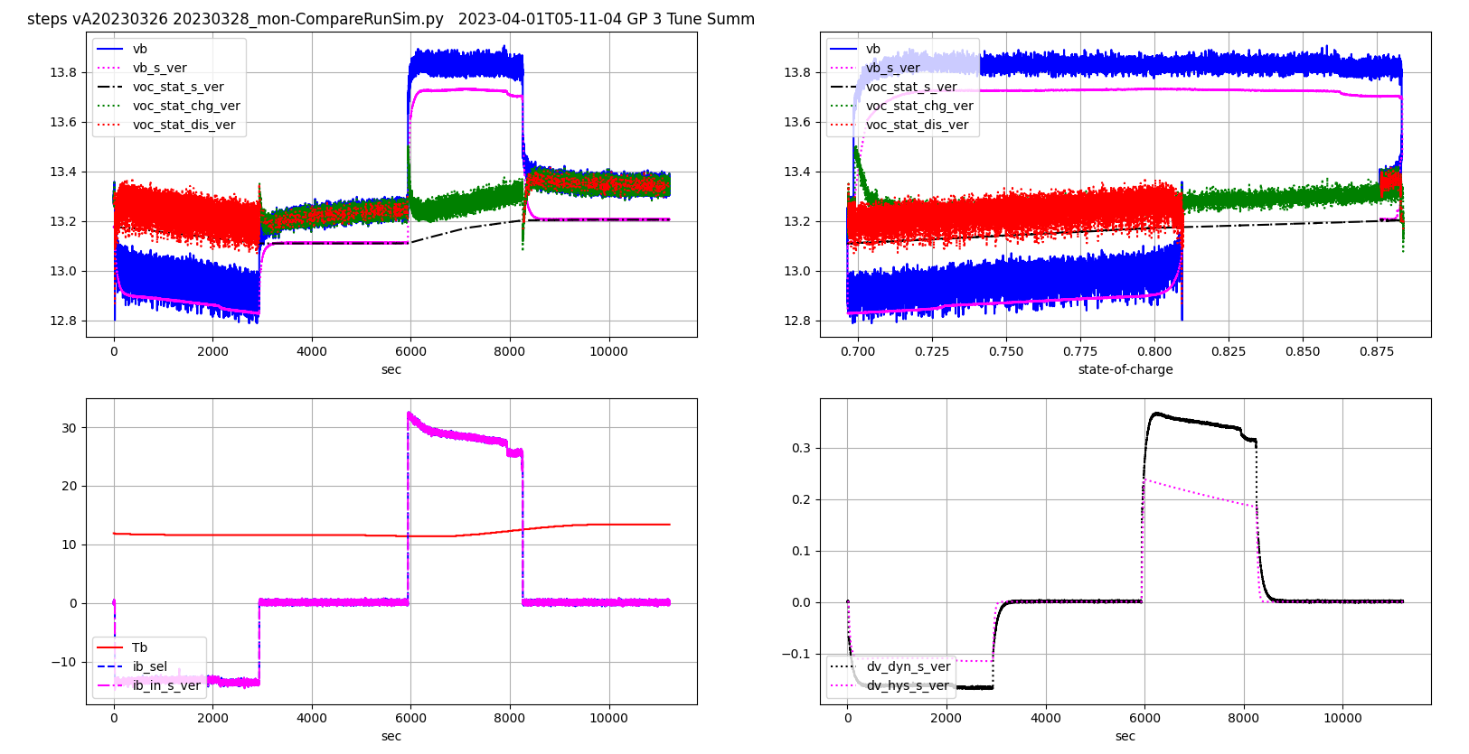Figure 11: Battleborn Argon Transients Around soc=0.8 As-installed
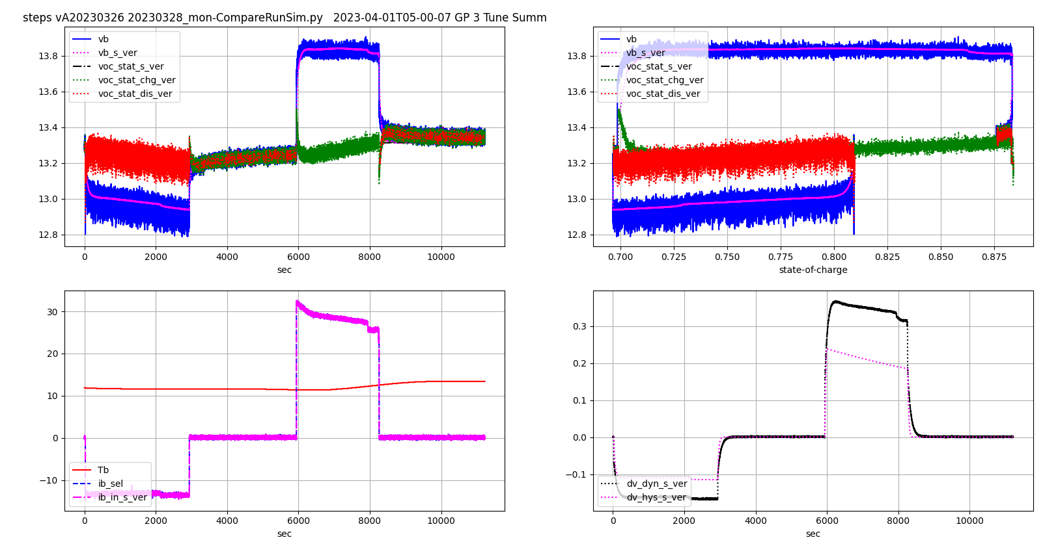Figure 12: Battleborn Argon Transients Around soc=0.8 Schedule Add 0.11 V

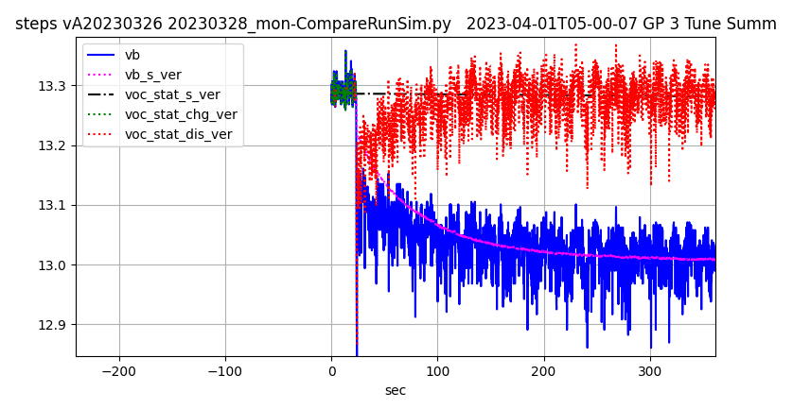Figure 13: Battleborn Argon Transients Around soc=0.8 Schedule Add 0.11 V Discharge Focus
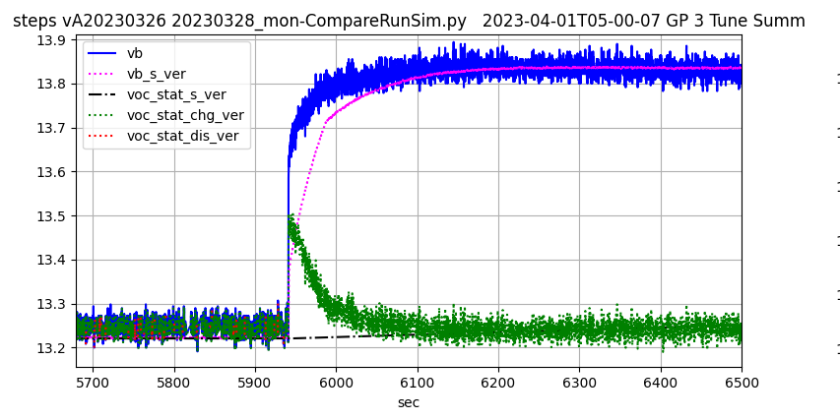Figure 14: Battleborn Argon Transients Around soc=0.8 Schedule Add 0.11 V Charge Focus
The overall view now show a match of vb_s_ver and vb. Moving on to the focused views we can now observe that the Randles resistance values need tuning to capture the initial jump better. I increased r_0 to from 0.0046 Ohms to 0.0113 Ohms to capture the initial step and then reduced r_ct from 0.0077 Ohms to 0.001 Ohms to preserve the overall resistance sum of 0.0123 Ohms. It is apparent by inspection that this will match up the discharge traces but there is a non-linear trend obvious in the charge trace caused by something else.

The something else is the hysteresis model that I proceeded to tweak by reducing resistance in the hysteresis to allow voltage to rise faster. The final results are shown in Figure 15, Figure 16, and Figure 17. The hysteresis tweak was small and arbitrary. Mainly my goal was to make the smallest possible tweak because the dataset is so small. I pulled the soc=1 curve down to 0.8 and reduced the resistance slightly while increasing the maximum limit on modeled hysteresis to 0.2 volts.
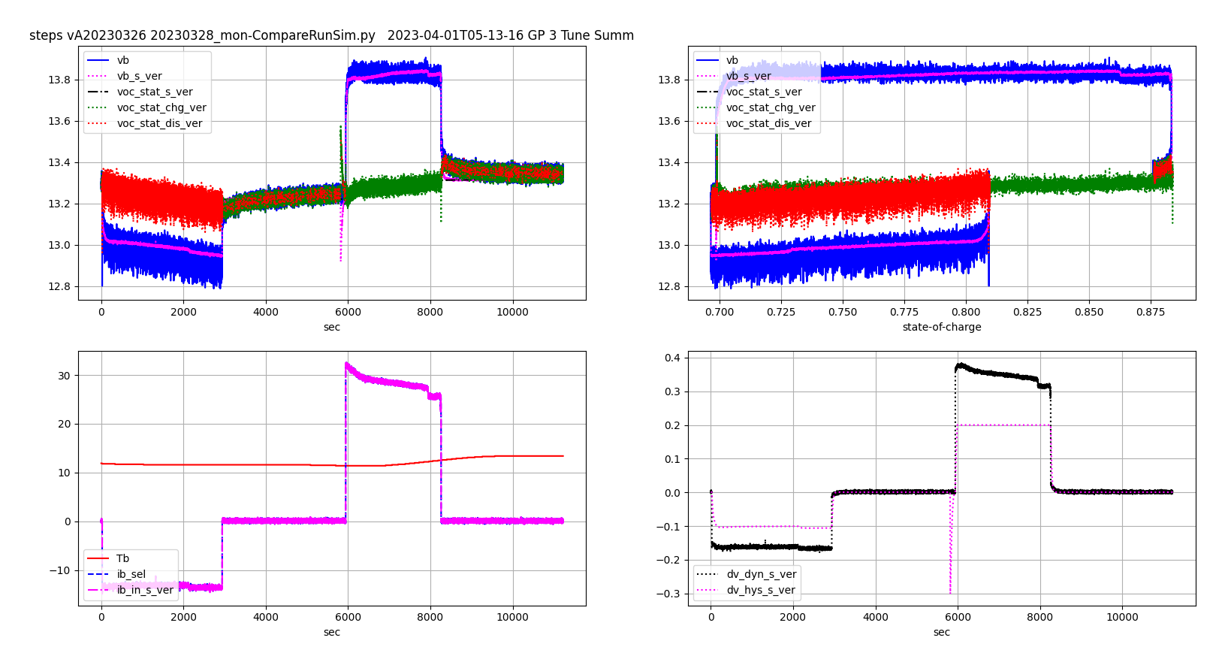Figure 15: Battleborn Argon Transients Around soc=0.8 Schedule Add 0.11 V Tune Hysteresis
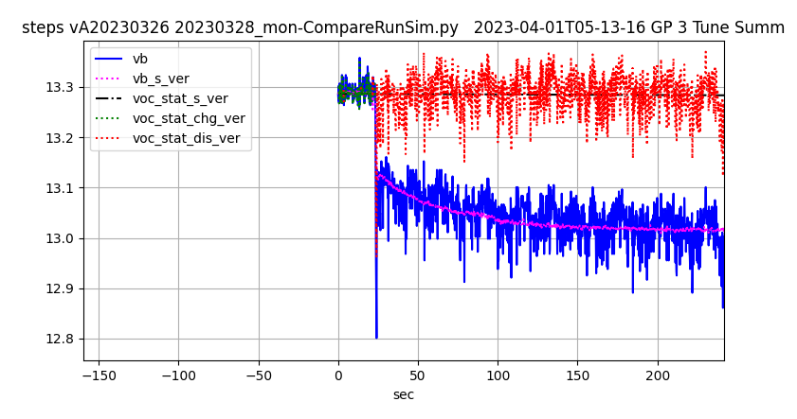Figure 16: Battleborn Argon Transients Around soc=0.8 Schedule Add 0.11 V Tune Hysteresis Discharge Focus

There is an artifact in the tuned transients just after 5800 seconds. This is caused by the data reduction program interpolating incoming data and I ignore it for now.
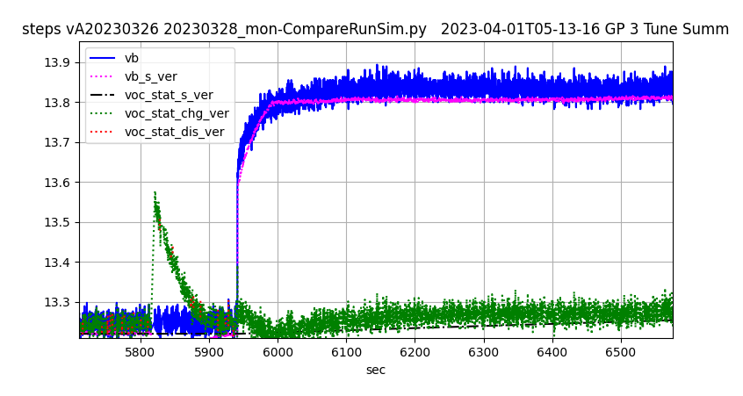Figure 17: Battleborn Argon Transients Around soc=0.8 Schedule Add 0.11 V Tune Hysteresis Charge Focus

The final schedules are below. The highlights indicate what changed from the original. I saw no reason the change tau_ct with this data set.

Condition | Randles r_0 | Randles  r_ct | Randles  tau_ct
all | 0.0113 | 0.0010 | 83
Table 6: Battleborn Battery Final Tuning

self.cap1 = 1e4 # scaled later
t_dv0 = [-0.7, -0.5, -0.3, 0.0, 0.15, 0.3, 0.7]
t_soc0 = [0, .5, .7]
t_s0 = [1., 1., 1., 1., 1., 1., 1.,
1., 1., 1., 1., 1., 1., 1.,
1., 1., 1., 1., 1., 1., 1.]
t_dv_min0 = [-0.7, -0.5, -0.3]
t_dv_max0 = [0.7, 0.3, 0.2]
t_r0 = [0.019, 0.015, 0.016, 0.009, 0.011, 0.017, 0.030,
0.014, 0.014, 0.010, 0.008, 0.010, 0.015, 0.015,
0.016, 0.016, 0.013, 0.005, 0.007, 0.010, 0.010]
Table 7: Battleborn Final Hysteresis Scheduling
t_x_soc0 = [-0.15, 0.00, 0.05, 0.10, 0.14, 0.17, 0.20, 0.25, 0.30, 0.40, 0.50, 0.60, 0.70, 0.80, 0.90, 0.99, 0.995,
1.00]
t_y_t0 = [5., 11.1, 20., 30., 40.]
t_voc0 = [4.00, 4.00, 4.00, 4.00, 10.20, 11.70, 12.45, 12.70, 12.77, 12.90, 12.91, 12.98, 13.05, 13.11, 13.17, 13.22, 13.59, 14.45,
4.00, 4.00, 4.00, 9.50, 12.00, 12.50, 12.70, 12.80, 12.90, 12.96, 13.01, 13.06, 13.11, 13.17, 13.20, 13.23, 13.60, 14.46,
4.00, 4.00, 10.00, 12.60, 12.77, 12.85, 12.89, 12.95, 12.99, 13.03, 13.04, 13.09, 13.14, 13.21, 13.25, 13.27, 13.72, 14.50,
4.00, 4.00, 12.00, 12.65, 12.75, 12.80, 12.85, 12.95, 13.00, 13.08, 13.12, 13.16, 13.20, 13.24, 13.26, 13.27, 13.72, 14.50,
4.00, 4.00, 4.00, 4.00, 10.50, 11.93, 12.78, 12.83, 12.89, 12.97, 13.06, 13.10, 13.13, 13.16, 13.19, 13.20, 13.72, 14.50]
+ 0.11
Table 8: Battleborn Final voc(soc) Scheduling. ‘+ 0.11’ Indicates Permanent Adjustment to Output
Values of Table (VM=VS=0.11)

There are a couple curiosities in the final tuning results.
- Very little hysteresis in Battleborn after relaxing to 0 current. There was no need to build flats into the schedules as in the CHINS (see the resistance = 0.4 values around 0 current in Table 4.) We may yet need that with more data.
- Double losses in CHINS: r_0 and r_ct. They have purposely designed for low cost – are increased losses a result?
- Shift of voc(soc) for Battleborn? Time will tell.
- Future Battleborn results will demonstrate that adding the missing 47 micro-Farad capacitor fixed the Vb noise.

Again, the hysteresis accuracy contributes to better fault detection and isolation by improving the accuracy of the EKF model. Coulomb counting of accurately measured current is what drives accuracy of Amp-Hours display on the device. The calibration performed here does not verify the accuracy of Coulomb Counting.

Since voltage sensing resets Coulomb Counters at saturation, memory of accumulated current measurement error gets lost. For this reason, an ‘infinity counter’ is being added that does not get reset. It will provide feedback to a user willing to dive deep and monitor that counter. Errors in counting accumulated over many discharge / charge cycles indicate either
- Current sensing error – CURR_BIAS_*, CURR_SCALE_*, SHUNT_GAIN (DA, DB, SB, SA, SG)
- Coulombic efficiency error – coul_eff ( not adjustable)
I believe that errors in the calibration are so large and variable of the battery so frequent that trying to tune the Coulombic efficiency more than the crude attempts contained in the code are a waste of time. The ‘game’ is to satisfactorily tune the current sensors to predict when the battery may die overnight withing about a half hour. And this will be difficult to prove, further supporting the claim that the fine tuning of Coulombic efficiency is a waste of effort. Despite the difficulty, it must be attempted. Amp-Hours remaining will be added to data collection and for history monitoring.

VBAT
It seemed like a good idea to monitor the VBAT EEPROM backup power battery voltage to alert the user when the battery dies. This applies to the Photon only. Argon uses EERAM device with a capacitor. The VBAT monitor did not work because the ADC converters appear to discharge the battery when connected to VBAT. The documentation for Particle device devices say the converters draw about 1/10 the power as the VBAT input. For some reason, this appears to be incorrect. The Photon is used inside the house while the Argon is used in the truck RV. The need for VBAT failure detection inside the house is unimportant.

Nomenclature
Capital letters always denote 'bank' parameters, what may be observed in the installation with several 100 A-h batteries in series-parallel configuration. 'nP' and 'nS' refer to the number of parallel and serial batteries respectively. If the bank is something other than 100 A-h batteries nP and nS may be scalar values. EG one 200 A-h battery would be nP=2, nS=1. Also, capacity may be scaled as well though it's most convenient to study these systems in 'units' of 100 A-h battery. My convention is the use the capacity scalar to manage the life effects. EG a new battery at 105% capacity would use scalar 'NOM_UNIT_CAP' and 'Sc' ('NOM_UNIT_CAP' and 'scale_in' in off-line). If these conventions are followed rigidly, then any data collected on the installed application may be converted into lower-case 'unit' parameters by simply multiplying and dividing by nS and nP making sure the scaling parameters are duplicated in the off-line model as parameter inputs input by hand.

Recommendations
- Procure TSC2010-IDT chips going forward.
- Procure 1% 1/4 watt resistors going forward.

